Assigment 4

Array Operation output

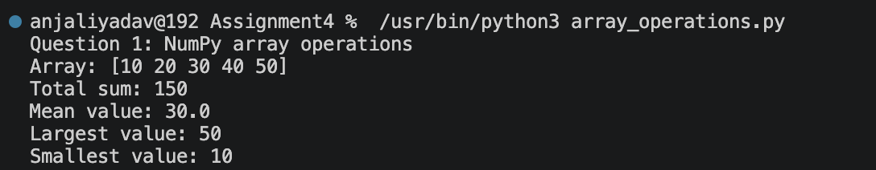

Matrix reshape output
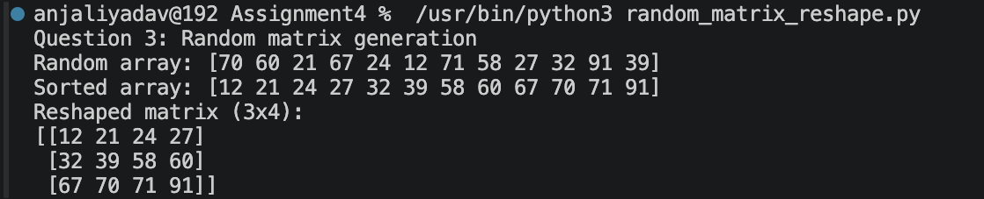

List Slicing output
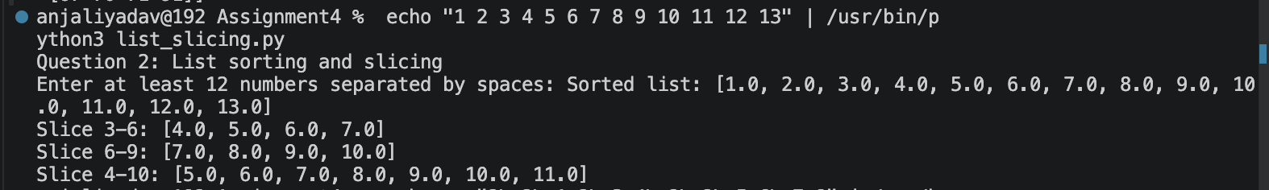

Matrix Operation Output

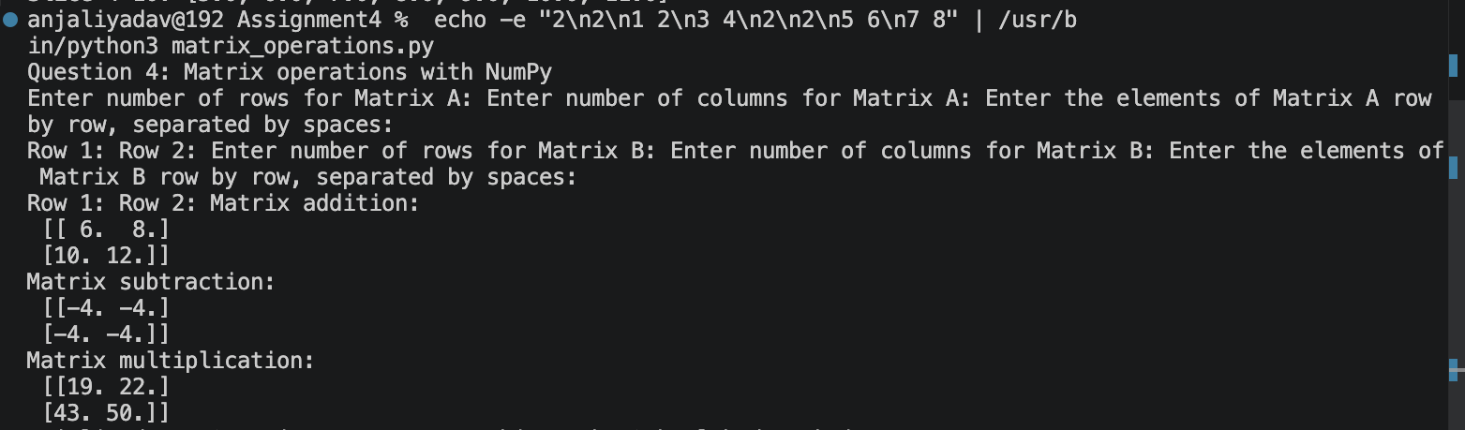

Health data Output
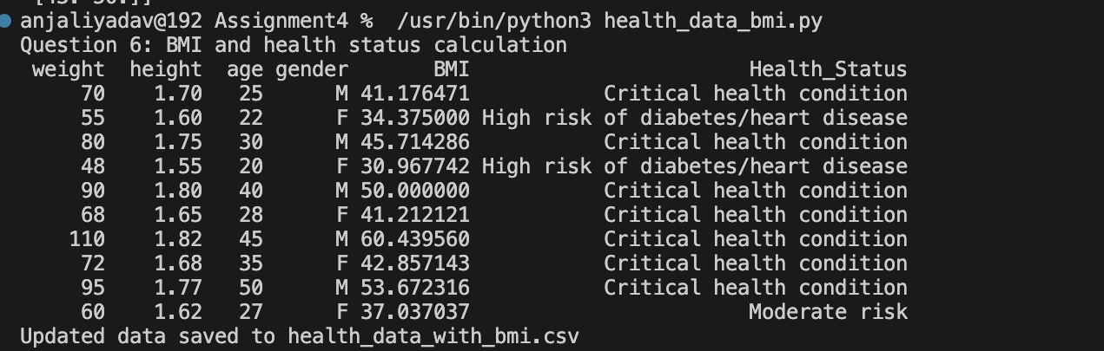

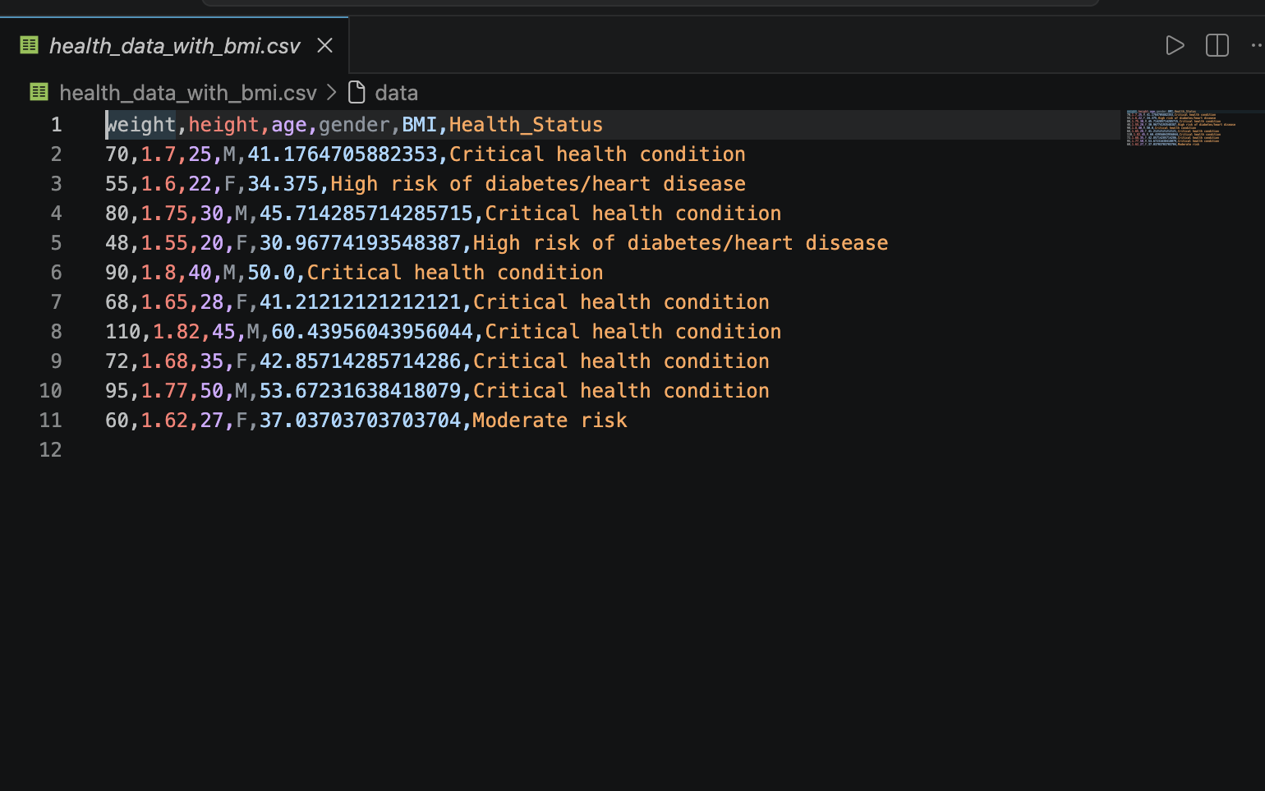

Health plot Output
